ASSIGNMENT NO. 2

NAME : POONAM KISHOR MUNDE

BRANCH : ENTC

DIVISION : ET2

BATCH : E21

PRN : 202501070141

SUBJECT : EDS(ESSENTIALS OF DATA SCIENCE)

CSV FILE :
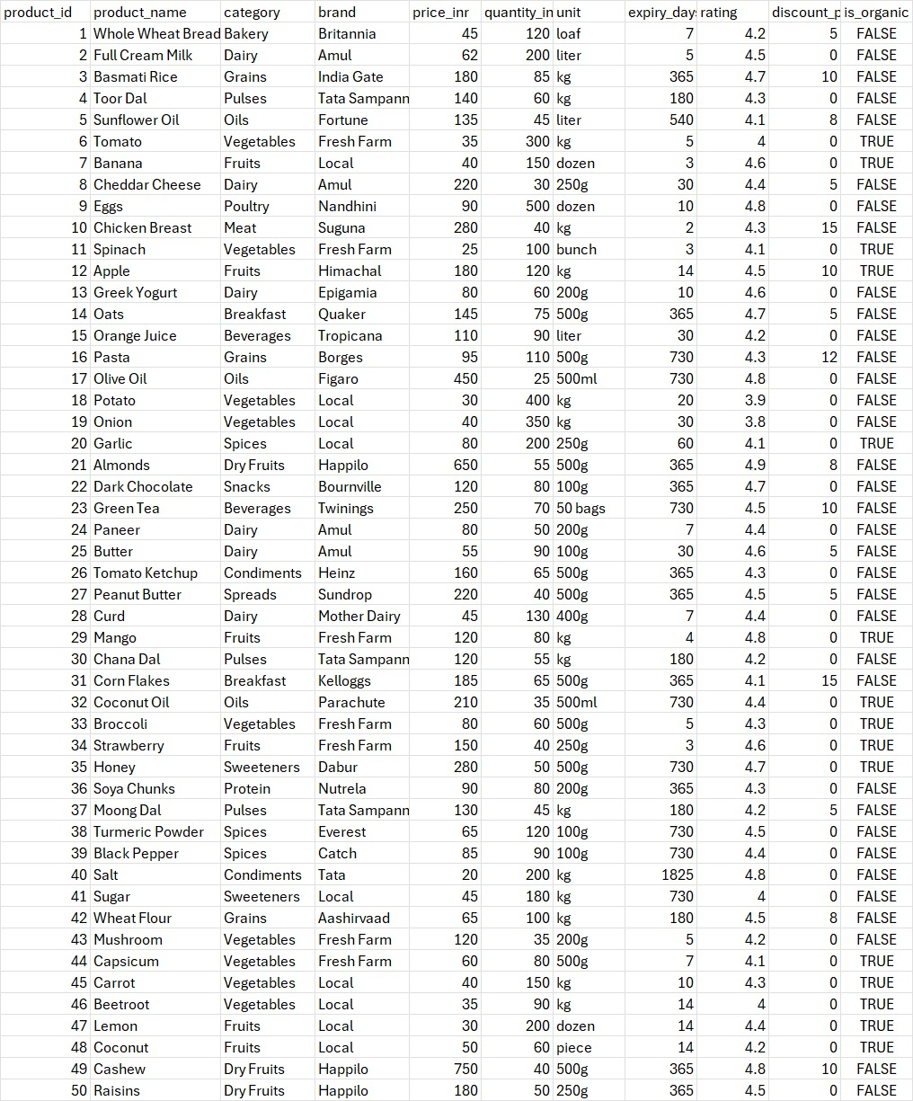

Q. 1. Find the average price of all products.
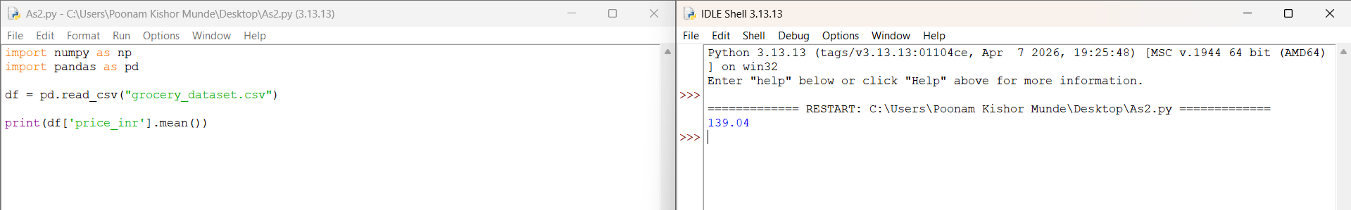

Q. 2. Find the most expensive product.
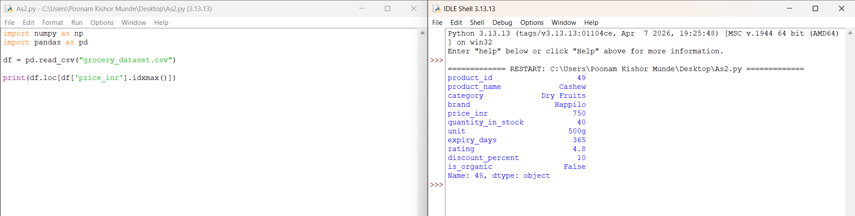
Q. 3. 2. Find the most cheapest product.
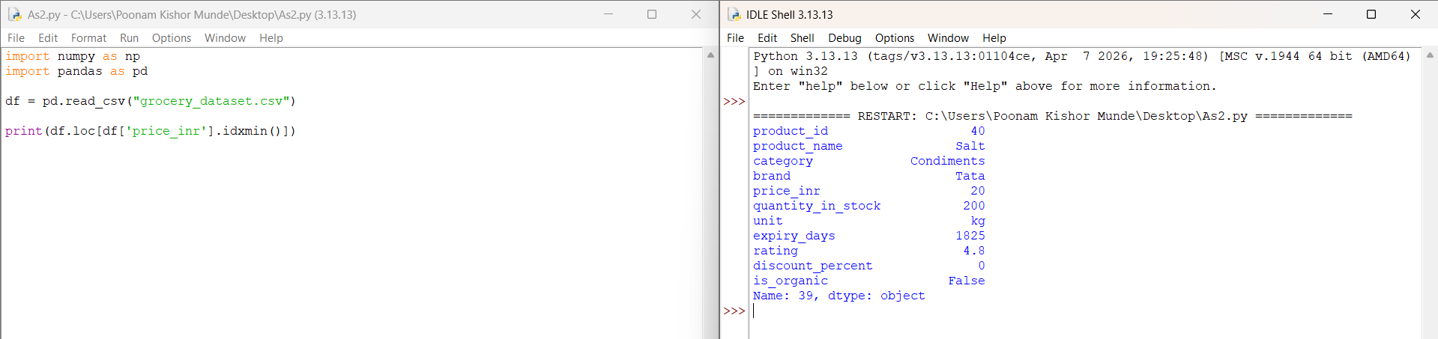

Q. 4. Count number of products in each category.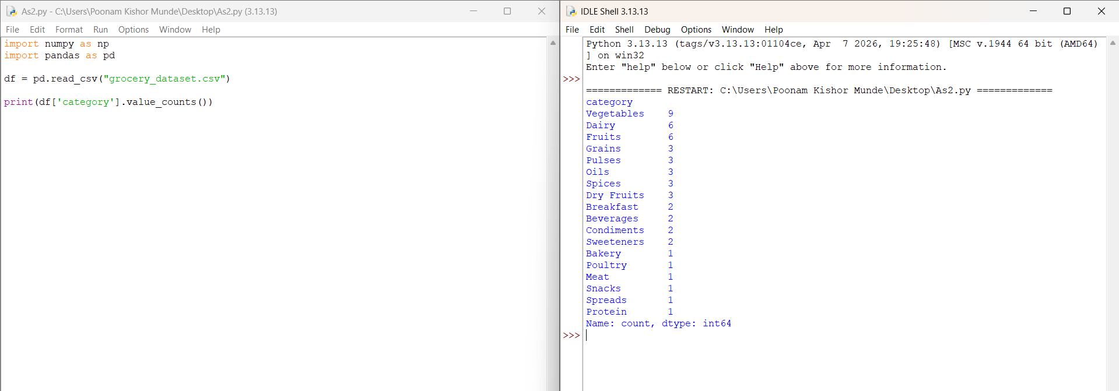
Q.5. Find average rating of organic vs non-organic products.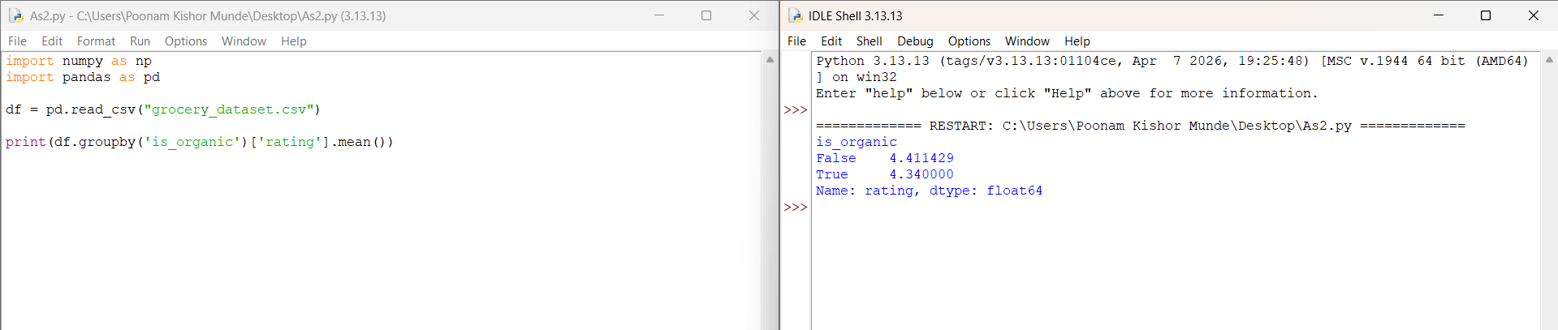
Q. 6. Find products with expiry less than 7 days.
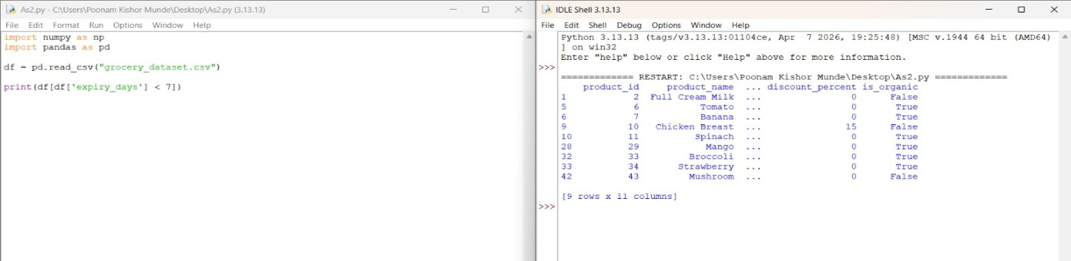

Q. 7. Find category with highest average price.
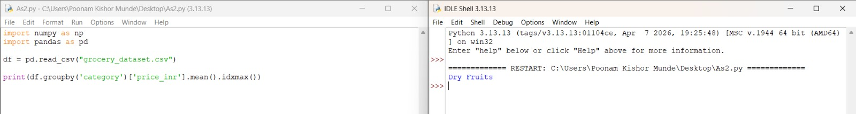

Q. 8. Find products with rating above 4.5.
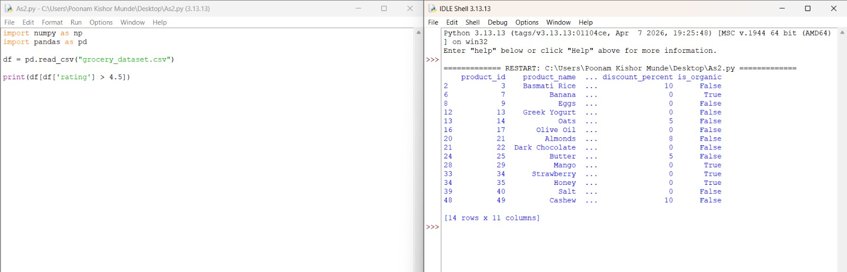

Q. 9. Find brand with most products.
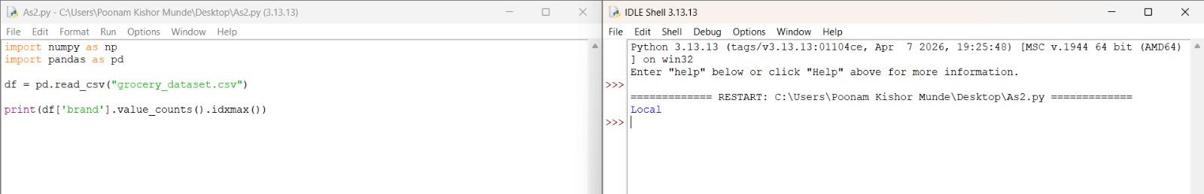
Q. 10. Find median price of products.
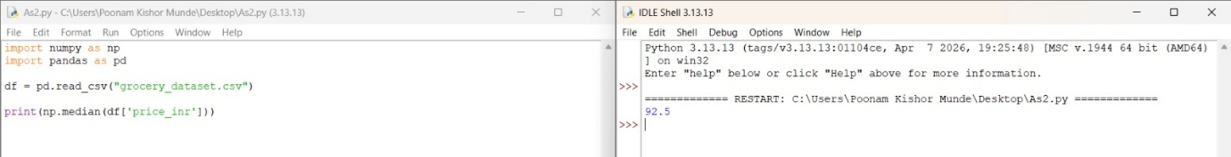
Q. 11. Find products whose price is above average.
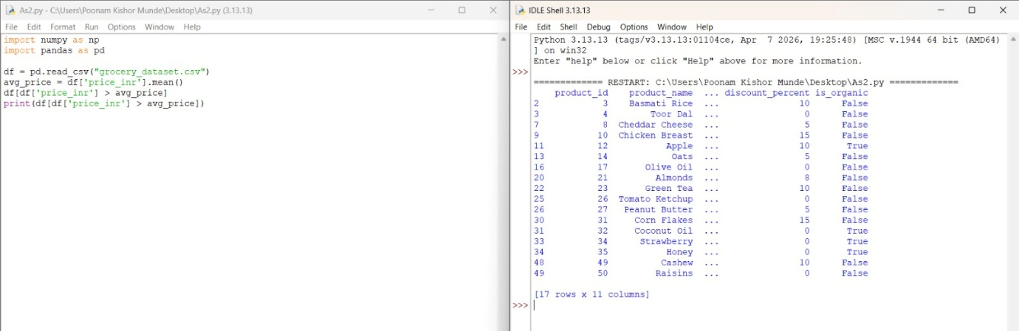
Q. 12. Find products expiring within 30 days and organic.
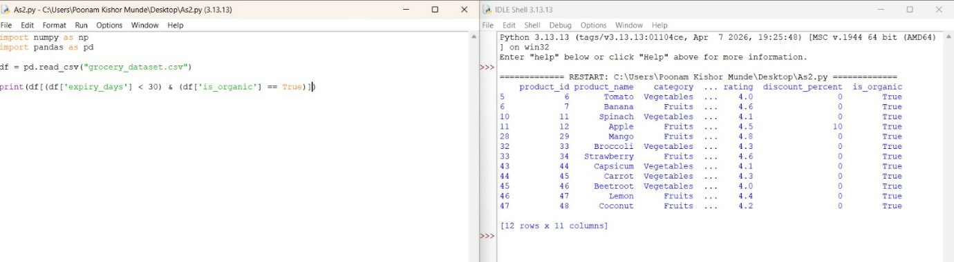

Q. 13. Find total number of organic products.
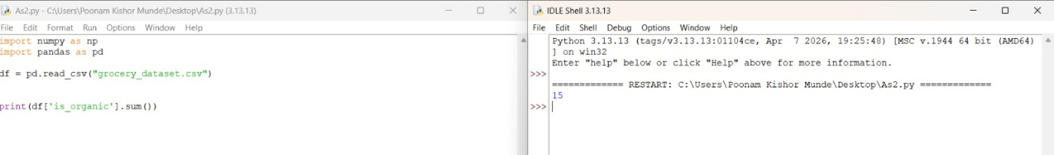
Q. 14. Calculate percentage of organic products.
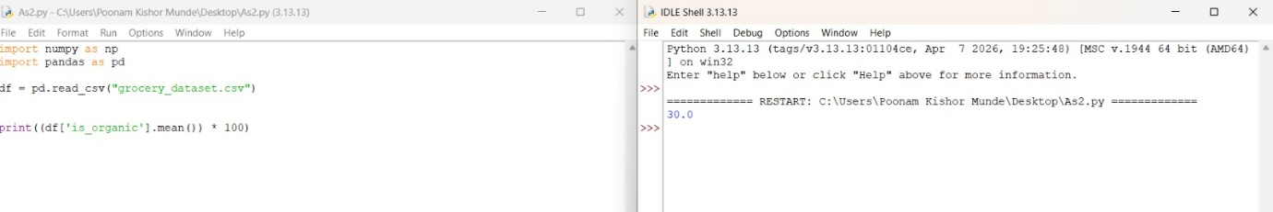
Q. 15. Find the product with longest shelf life.
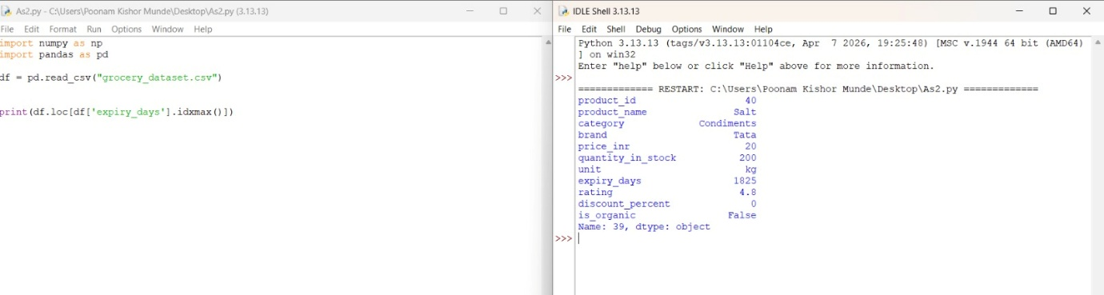Q. 16. Find correlation between price and rating.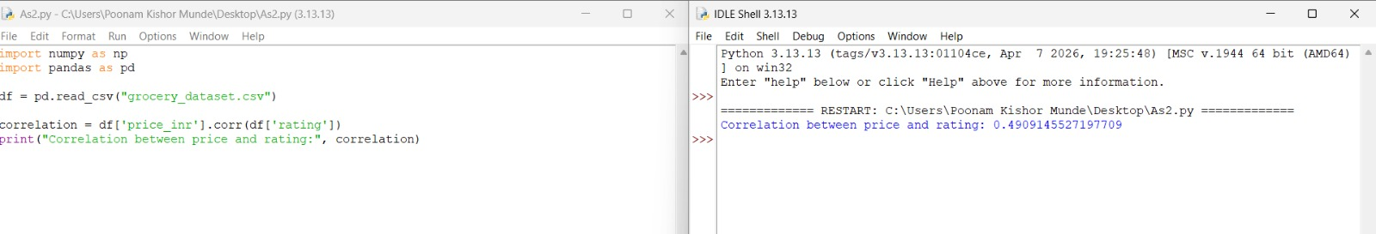
Q. 17. Find average price for each brand.
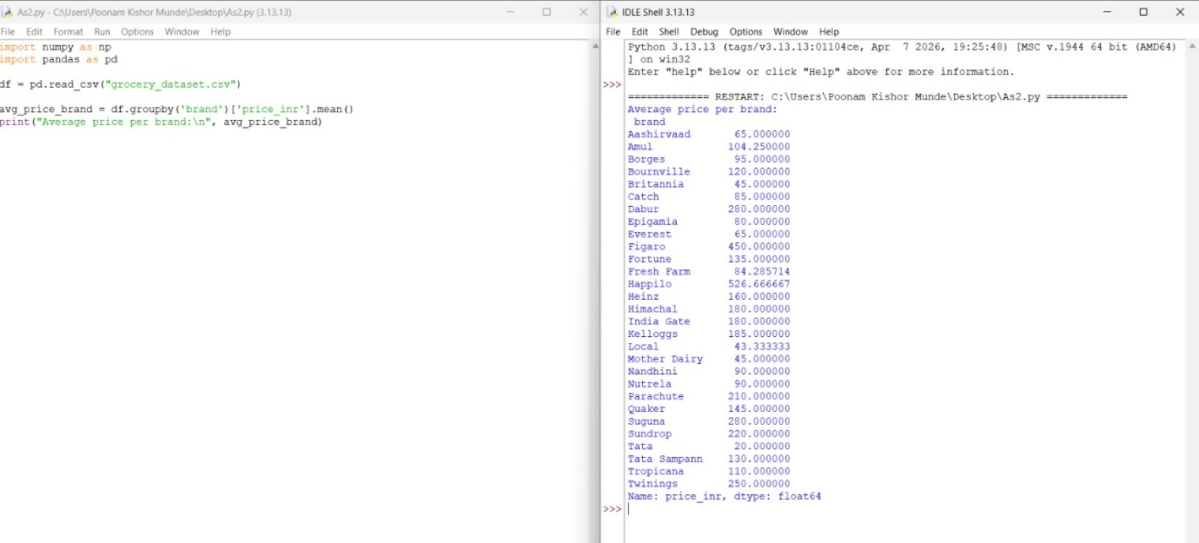
Q. 18. Count number of products in each category.
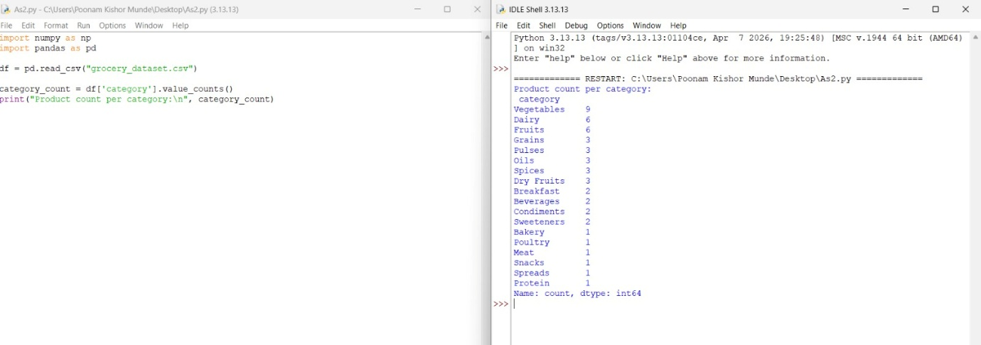

Q. 19. Find average rating per category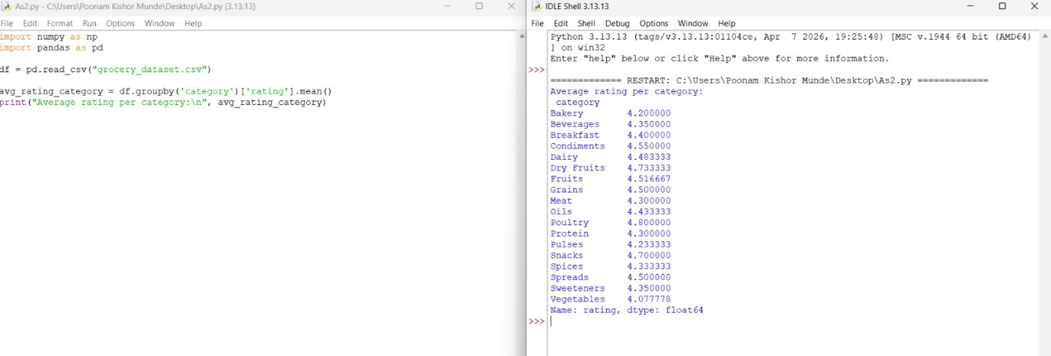

Q. 20. Find top 5 highest rated products.
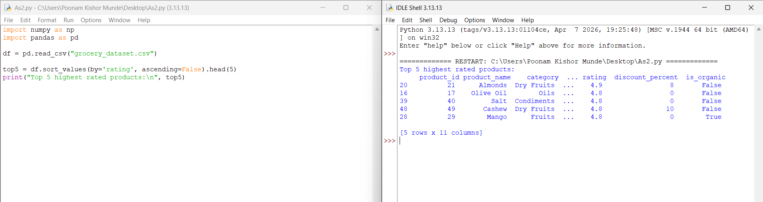

THANK YOU

